Operating Committee
PJM Conference & Training Center, Audubon, PA
March 5, 2019
9:00 a.m. – 12:00 p.m. EPT

Administration (9:00 – 9:05)
- Approve Operating Committee (OC) Agenda for this meeting.
- Review and approve Draft Minutes of the February 5, 2019 OC meeting.
- Review of the OC Work Plan.

Review of Operations (9:05 – 9:20)
- Review of Operational Events
Mr. Chris Pilong, PJM, will review PJM operations since the last OC meeting.
- Review of Operating Metrics
Ms. Stephanie Monzon, PJM, will review the February 2019 PJM operating metrics slides. Metrics will include PJM’s load forecast error, BAAL performance, transmission / generation outage statistics, and Perfect Dispatch historical performance.

Endorsements / Approvals (9:20 – 9:45)
- Manual 13 Changes
Mr. Chris Pilong, PJM, will review the proposed changes to Manual 13: Emergency Operations. The Operating Committee will be asked to endorse these changes.

- Manual 37 Changes
Mr. Donnie Bielak, PJM, will review the proposed changes to Manual 37: Reliability Coordination. The Operating Committee will be asked to endorse these changes.

- Non-Retail BTMG Business Rules Problem Statement and Issue Charge
Ms. Terri Esterly, PJM, will review the Non-Retail BTMG Business Rules Problem Statement and Issue Charge. The Operating Committee will be asked to endorse the Problem Statement and Issue Charge.

First Readings (9:45 – 9:45)
There are no first readings for this month’s meeting.

OC Subcommittee / Task Force Updates (9:45 – 10:00)
- System Operations Subcommittee (SOS)
Mr. Chris Pilong, PJM, will provide a summary of the most recent SOS meeting.

- Data Management Subcommittee (DMS)
There are no DMS updates for this month’s meeting.
- Distributed Energy Resources Subcommittee (DERS)
There are no DERS updates for this month’s meeting.
- System Restoration Coordinators Subcommittee (SRCS)
There are no SRCS updates for this month’s meeting.
- Primary Frequency Response Sr. Task Force (PFRSTF)
There are no PFRSTF updates for this month’s meeting.

Unit Specific Parameter Adjustment Updates (10:00 – 10:10)
- Unit Specific Parameter Updates
Ms. Lauren Strella, PJM, will provide an update on Unit Specific Parameters.

PJM Initiatives/Education Updates (10:10 – 10:20)
- Fuel Requirements for Black Start Resources Update
Ms. Janell Fabiano, PJM, will provide an update from PJM’s Fuel Requirements for Black Start Resources Special Session. More information on this initiative can be found at PJM’s Issues Tracking page. https://www.pjm.com/committees-and-groups/issue-tracking/issue-tracking-details.aspx?Issue={B7F726E1-9F06-414E-8516-4D69B5050AF4}

Break (10:20 – 10:30)

Tool and Informational Updates (10:30 – 12:00)
- System Resilience
Mr. Jonathon Monken, PJM, will provide an update on PJM’s Resilience Roadmap efforts.

- Frequency Response Performance and Updates
Ms. Danielle Croop, PJM, will provide an update on PJM’s frequency response performance. Additionally, Ms. Croop will provide an informational update regarding NERC’s March 26 Project 2017-01 Modifications to BAL-003-1.1 Technical Conference.

- Synchronous Reserve Updates
Mr. David Kimmel, PJM, will provide an update on synchronous reserve performance.
`
- Reliability Compliance Update
Mr. Preston Walker, PJM, will provide an update on NERC, SERC and RFC standards, and other pertinent regulatory and compliance information, and solicit feedback from the members on Reliability Compliance efforts.

- PJM.com Homepage Redesign Update
Mr. Chad Hutchinson, PJM, will provide a live demonstration of the upcoming changes to the PJM.com homepage.

- NERC Lessons Learned
There are no NERC lessons learned for this month’s meeting.

- Pricing Interface Update
There have been no newly created pricing interfaces.

Action Items (12:00)
- PJM will provide educational sessions regarding the DER collection, modelling and forecasting.

Future Meeting Dates
April 9, 2019 | 9:00 a.m. | PJM Interconnection - Conference and Training Center
May 14, 2019 | 9:00 a.m. | PJM Interconnection - Conference and Training Center
June 11, 2019 | 9:00 a.m. | PJM Interconnection - Conference and Training Center
July 09, 2019 | 9:00 a.m. | PJM Interconnection - Conference and Training Center

Author: Don Wallin

Antitrust:
You may not discuss any topics that violate, or that might appear to violate, the antitrust laws including but not limited to agreements between or among competitors regarding prices, bid and offer practices, availability of service, product design, terms of sale, division of markets, allocation of customers or any other activity that might unreasonably restrain competition. If any of these items are discussed the chair will re-direct the conversation. If the conversation still persists, parties will be asked to leave the meeting or the meeting will be adjourned.

Code of Conduct:
As a mandatory condition of attendance at today's meeting, attendees agree to adhere to the PJM Code of Conduct as detailed in PJM Manual M-34 section 4.5, including, but not limited to, participants' responsibilities and rules regarding the dissemination of meeting discussion and materials.

Public Meetings/Media Participation:
Unless otherwise noted, PJM stakeholder meetings are open to the public and to members of the media. Members of the media are asked to announce their attendance at all PJM stakeholder meetings at the beginning of the meeting or at the point they join a meeting already in progress. Members of the Media are reminded that speakers at PJM meetings cannot be quoted without explicit permission from the speaker. PJM Members are reminded that "detailed transcriptional meeting notes" and white board notes from "brainstorming sessions" shall not be disseminated. Stakeholders are also not allowed to create audio, video or online recordings of PJM meetings. PJM may create audio, video or online recordings of stakeholder meetings for internal and training purposes, and your participation at such meetings indicates your consent to the same.

Participant Identification in WebEx:
When logging into the WebEx desktop client, please enter your real first and last name as well as a valid email address. Be sure to select the “call me” option.
PJM support staff continuously monitors WebEx connections during stakeholder meetings. Anonymous users or those using false usernames or emails will be
dropped from the teleconference.
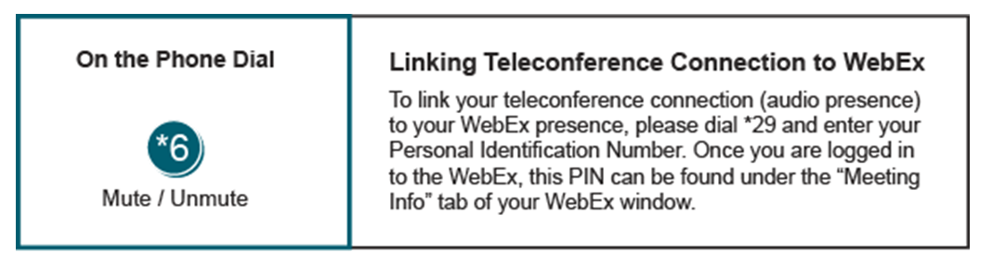
Provide feedback on the progress of this group: Facilitator Feedback Form
Visit learn.pjm.com, an easy-to-understand resource about the power industry and PJM’s role.

