Planning Committee
PJM Conference and Training Center, Audubon, PA
August 10, 2017
9:30 a.m. – 12:15 p.m. [EPT]

Administration (9:30 – 9:35)
- Welcome, announcements and review of the Anti-trust, Code of Conduct, and Media Participation Guidelines. - Mr. Paul McGlynn
- Approve draft minutes from the July 13th, 2017 Planning Committee (PC) meeting.

Endorsements (9:35 – 10:15)
- TO/TOP Matrix V11 Update
Mr. Srinivas Kappagantula, PJM, will present the TO/TOP Matrix V11. The committee will be asked to provide their recommendation for the TOA-AC for approval.
- PJM Manual 14B – NYISO/PJM Wheel Replacement
Mr. Michael Herman, PJM, will present updates to Manual 14B (PJM Regional Transmission Process) to reflect modeling in CETL simulations resulting from the NYSIO/PJM Wheel cancellation, clarification of the CIL calculation method and also update the PJM System Planning department responsibilities. The committee will be asked to endorse these updates to Manual 14B.

First Readings (10:15 – 10:35)
- PJM Manual 14A
Mr. Joe Hay, PJM, will present proposed updates to Manual 14A (Generation and Transmission Interconnection Process). These updates were identified as part of the biennial review of the manual. The committee will be asked to endorse these updates at its next meeting.

Informational Updates (10:35 – 12:15)
- Light Load Analysis
Mr. Mark Sims, PJM, will review the proposed approach to update the Light Load Reliability Test procedure parameters.
- Grid Resilience in System Planning
Mr. Sims, PJM, will discuss grid resilience in Transmission Planning as well as next steps.
- Relay Subcommittee request for NERC P5 stability contingencies and clearing times
Mr. Stan Sliwa, PJM, will provide an update on the Relay Subcommittee request for NERC P5 stability contingencies and clearing times.

- RTEP 2018 Schedule Update
Mr. Jason Connell, PJM, will provide an update regarding the RTEP 2018 Schedule.
- Winter Season Resource Adequacy and Capacity Requirements
Mr. Tom Falin, PJM, will provide an update on recent work related to the MRC problem statement regarding winter season resource adequacy and capacity requirements.
- New Service Request Study Methods
Mr. Aaron Berner, PJM, will provide an update on the progress of the new service request study methods.
- Power Systems Engineering Division (PSED) Technical Workshop
Mr. Aaron Berner, PJM, will provide an update regarding the Mitsubishi Electric Power Products, Inc. (MEPPI) Power Systems Engineering Division (PSED) Technical Workshop from September 25 through September 27. Those interested can sign up using the following link: http://pjm.com/Calendar-Events/PJM-Calendars/Training-Events/2017/September/25/ip-psed-technical-workshop.aspx
- NERC and Regional Coordination Update
Mr. Preston Walker, PJM, will provide an update on the activities, issues and items of interest at NERC, SERC, and RFC.
- 2017 Stakeholder Satisfaction Survey
Ms. Janell Fabiano, PJM, will provide an update regarding the 2017 Stakeholder Satisfaction Survey.

Informational Updates
Designated Entity Design Standards Task Force (DEDSTF) Update
The DEDSTF continues with monthly meetings to finalize the Underground and HVDC sections within the Lines section of the DEDSTF Requirements document. At the 8/17 meeting, we expect to finalize the wording for the Underground lines, and at the 9/7 meeting we will have a subject matter expert lead us through discussions on design and requirements of HVDC facilities. All are welcome to participate, please register on the DEDSTF page of pjm.com. We expect to bring these updated sections back to the planning committee for endorsement in 2017 Q4.
Order 1000 Projects and Cost Capping/Cost Commitment Special PC Meeting
On July 18, PJM conducted a Special PC meeting to continue discussion of Cost Capping/Cost Commitment. The topic of the meeting was focused on roles and responsibilities with respect to Cost Commitment and the development of potential draft principles was initiated. The next meetings are scheduled for August 21, September 8, and October 9 to continue development of principles.

Future Meeting Dates
August 21, 2017 | 9:30 a.m. | Special PC: Consideration of Cost Cap/Containment Provisions for Competitive Proposals | PJM Conference and Training Center, Audubon, PA
August 25, 2017 | 1:00 p.m. | Special PC: New Service Request Study Methods | Teleconference Only
September 8, 2017 | 1:00 p.m. | Special PC: Consideration of Cost Cap/Containment Provisions for Competitive Proposals | PJM Conference and Training Center, Audubon, PA
September 14, 2017 | 9:30 a.m. | Planning Committee | PJM Conference and Training Center, Audubon, PA
October 9, 2017 | 9:30 a.m. | Special PC: Consideration of Cost Cap/Containment Provisions for Competitive Proposals | PJM Conference and Training Center, Audubon, PA
October 12, 2017 | 9:30 a.m. | Planning Committee | PJM Conference and Training Center, Audubon, PA
November 9, 2017 | 9:30 a.m. | Planning Committee | PJM Conference and Training Center, Audubon, PA
December 14, 2017 | 9:30 a.m. | Planning Committee | PJM Conference and Training Center, Audubon, PA

Author: Bridgid Cummings

Anti-trust:
You may not discuss any topics that violate, or that might appear to violate, the antitrust laws including but not limited to agreements between or among competitors regarding prices, bid and offer practices, availability of service, product design, terms of sale, division of markets, allocation of customers or any other activity that might unreasonably restrain competition. If any of these items are discussed the chair will re-direct the conversation. If the conversation still persists, parties will be asked to leave the meeting or the meeting will be adjourned.

Code of Conduct:
As a mandatory condition of attendance at today's meeting, attendees agree to adhere to the PJM Code of Conduct as detailed in PJM Manual M-34 section 4.5, including, but not limited to, participants' responsibilities and rules regarding the dissemination of meeting discussion and materials.

Public Meetings/Media Participation:
Unless otherwise noted, PJM stakeholder meetings are open to the public and to members of the media. Members of the media are asked to announce their attendance at all PJM stakeholder meetings at the beginning of the meeting or at the point they join a meeting already in progress. Members of the Media are reminded that speakers at PJM meetings cannot be quoted without explicit permission from the speaker. PJM Members are reminded that "detailed transcriptional meeting notes" and white board notes from "brainstorming sessions" shall not be disseminated. Stakeholders are also not allowed to create audio, video or online recordings of PJM meetings.

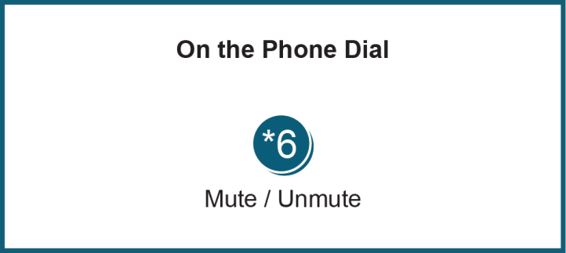

Facilitator Feedback Form: http://www.pjm.com/committees-and-groups/committees/form-facilitator-feedback.aspx

