Generator Offer Flexibility Senior Task Force (Meeting #2)
PJM Conference and Training Center / WebEx
June 29, 2015
9:30 p.m. – 4:00 p.m. [EPT]

Administration (9:30-9:45)
- Welcome, roll call, review of PJM meeting guidelines and June 19th meeting minutes.

Monitoring Analytics Education Presentation (9:45-10:45)
- Monitoring Analytics, LLC will provide education material for current day-ahead and real time offer rules in the PJM market.

Break (10:45-11:00)

Options Matrix Presentation (11:00-12:00)
- PJM will present an initial long-term proposal. Stakeholders will be asked for input on additional design components and options.

Lunch (12:00 – 12:45)

Timeline of FERC 206 Proceeding (12:45 – 1:00)
- Mr. Adam Keech, PJM Interconnection, LLC, will present PJM’s timeline to comply with FERC’s 206 proceeding related to hourly offers in the DA and RT markets.

NYISO Education Presentation (1:00 – 2:00)
- Mr. Michael DeSocio, New York ISO, will present education for day-ahead and real-time generator offers in the NYISO Market.

Break (2:00-2:15)

Options Matrix Discussion (2:15-3:45)
- Stakeholders will be asked for additional input on design components and options.

Future Agenda Items (3:45-3:55)
- Options Matrix development

Future Meeting Dates (3:55-4:00)
July 10th | 9:30am – 4:00pm | Conference and Training Center / WebEx
July 22nd | 9:30am – 4:00pm | Conference and Training Center / WebEx
August 4th | 9:30am – 4:00pm | Conference and Training Center / WebEx
August 21st | 9:30am – 4:00pm | Conference and Training Center / WebEx
September 4th | 9:30am – 4:00pm | Conference and Training Center / WebEx
September 23rd | 9:30am – 4:00pm | Conference and Training Center / WebEx

Author: B. Chmielewski

Anti-trust:
You may not discuss any topics that violate, or that might appear to violate, the antitrust laws including but not limited to agreements between or among competitors regarding prices, bid and offer practices, availability of service, product design, terms of sale, division of markets, allocation of customers or any other activity that might unreasonably restrain competition. If any of these items are discussed the chair will re-direct the conversation. If the conversation still persists, parties will be asked to leave the meeting or the meeting will be adjourned.

Code of Conduct:
As a mandatory condition of attendance at today's meeting, attendees agree to adhere to the PJM Code of Conduct as detailed in PJM Manual M-34 section 4.5, including, but not limited to, participants' responsibilities and rules regarding the dissemination of meeting discussion and materials.

Public Meetings/Media Participation:
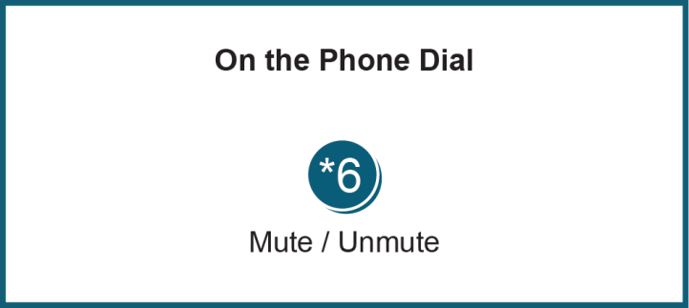
Unless otherwise noted, PJM stakeholder meetings are open to the public and to members of the media. Members of the media are asked to announce their attendance at all PJM stakeholder meetings at the beginning of the meeting or at the point they join a meeting already in progress. Members of the Media are reminded that speakers at PJM meetings cannot be quoted without explicit permission from the speaker. PJM Members are reminded that "detailed transcriptional meeting notes" and white board notes from "brainstorming sessions" shall not be disseminated. Stakeholders are also not allowed to create audio, video or online recordings of PJM meetings.

